Behaviour change for climate action – yes please! But how can we make it happen?

Climate Action Durham was delighted to welcome Jack Hughes, PhD student and researcher in Psychology and Behavioural Science at Durham University. Jack shared his insights with an engaged audience at the Durham Town Hall on 25 March, 2022.

When it comes to climate change, we all know that individual action when collectively imposed can make a big difference. Jack gave real world examples to show how small changes, when informed by research, can generate large scale behavioural change. Whether trying to reduce littering, increase cycling, change consumption habits, or anything else. Jack introduced the EAST framework (Easy, Attractive, Social, Timely) which helps designing good nudges. He used the framework to clarify that the key issue is to design effective behavioural interventions rather than the literal nudge itself.

For example, it can be shown that coloured cycle lanes significantly reduce the number of cars parked on them and that they significantly increase the number of people using them. Wouldn’t that be a timely intervention in Durham to help cyclists not only feel but be safer whilst cycling and reducing traffic-based greenhouse gases (and reducing air pollution and getting fit)?
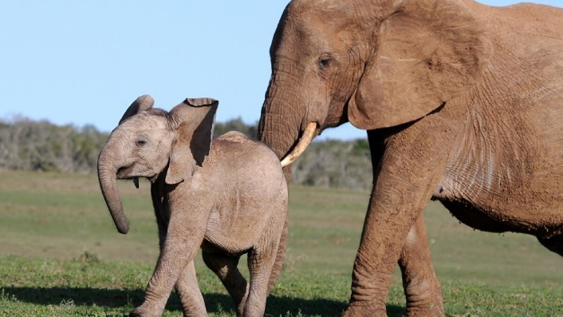
Caption: Building effective behavioural interventions is more than just giving a nudge.

Jack is a member of Durham University’s Psychologists for Environmental Action (PEAs), a pressure group, research team, and activist collective, looking to create a sustainable psychology department in Durham and to bring our knowledge of environmental psychology and behaviour science to the community. Get in contact by emailing peas.psychology@durham.ac.uk if you want to be involved, help with research, or join our events.

Climate Action Durham is grateful to Jack for his talk and for establishing the connection with PEAs. We believe there is huge potential in joining Durham University-based groups and individuals with local climate action and look forward to more insights and inspiration from those peas in that pod.

