Title Slide
RENEWABLE ENERGY:
POLITICS, PLANNING AND SNIPERLEY PARK
Grenville Holland
November 4th, 2022

Slide 1

Renewable Energy: Lord William Armstrong and Cragside (1869)
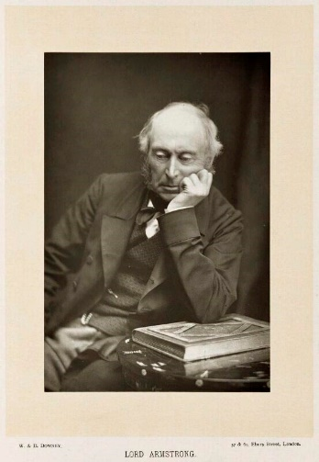

In 1863 Armstrong said coal "was used wastefully and extravagantly in all its applications"

He predicted that Britain would cease to produce coal within two centuries.

He was one of the very first advocates of moving away from fossil fuels to water and solar power

Slide 2
The UK’s Energy Provision - 294 TWh per year

Renewable energy opportunities
Solar
Wind
Heat exchange – ground/water/geothermal
Tidal – barrage/wave
Hydro schemes
Biofuel
SITA/SUEZ – Burning Waste
54TWh = 18.4% cf Sweden = 60.1%

Nuclear – large and small - zero carbon
66TWh = 22.4%

Slide 3
County Durham Plan - May 2020
New Housing Estates in County Durham
Housing and Employment Land
Allocates over 300 hectares of new land
Envisages 24,852 new homes across the County by 2035

Slide 4
1750 New Houses at Sniperley Park
Green Belt released by the Inspector in the 2020 Durham County Plan for the creation of a large new estate NW of Durham City.
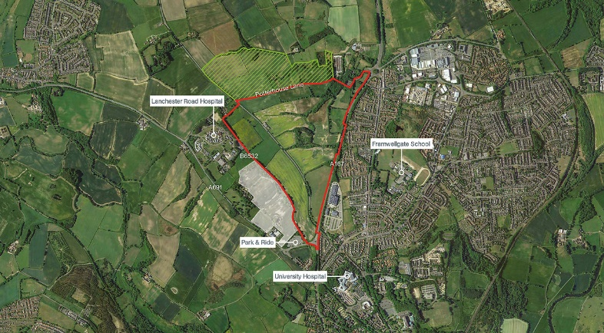

Slide 5
Introducing Renewable Energy at Sniperley Park
Key Planning Guidance: NPPF 2021
Section 14. Meeting the challenge of climate change, flooding and coastal change
Paragraph 155. To help increase the use and supply of renewable and low carbon energy and heat.

Slide 6
Introducing Renewable Energy at Sniperley Park
Key Planning Guidance: CDP 2020 Policy 5
Durham City's Sustainable Urban Extensions
“Development is required to be comprehensively master planned”
Development will comprise of 1,750 houses at Sniperley Park.
- opportunities for a district heating network will be explored given the site's proximity to Lanchester Road Hospital and Aykley Heads.

Objective 17: Low Carbon - Reduce the causes of climate change and support the transition to a low carbon economy by encouraging and enabling the use of low and zero carbon technologies, supporting the development of appropriate renewable energy sources and sustainable and active transport.

Slide 7
Introducing Renewable Energy at Sniperley Park
Key Planning Guidance: CDP 2020 Policy 29
Sustainable Design
c. Minimise greenhouse gas emissions, by seeking to achieve zero carbon buildings and providing renewable and low carbon energy generation and include connections to an existing or approved district energy scheme where viable opportunities exist. Where connection to the gas network is not viable, development should utilise renewable and low carbon technologies as the main heating source

Core Principle 5.292 The built environment accounts for over half of the UK’s CO₂ emissions, through both construction and use. Development must therefore target Zero Carbon Buildings through energy efficiency and include renewable and low carbon energy technologies to mitigate carbon dioxide emissions.

Slide 8
Introducing Renewable Energy at Sniperley Park
Key Planning Guidance: Sniperley Park Masterplan July 2022
“The Masterplan will be a material consideration against which any planning application on the site will be assessed.”

“Durham County Council’s vision for Sniperley Park is that of a high quality, zero carbon well designed community that will stand the test of time and leave a legacy which Durham will be proud of.”

“Principle 12: Aspiring to a zero-carbon development”
“This should include provision of onsite electric and non-fossil fuel-based heat production, consideration of Passivhaus construction and extensive biodiversity net gain.”

Slide 9
Introducing Renewable Energy at Sniperley Park
Design Proposal: City of Durham Parish Council
1. An Energy Assessment for the entire site designed to minimise energy consumption and greenhouse gas emissions with all properties satisfying the now updated 2030 operational energy and embodied carbon targets set by the RIBA 2030 Challenge which identify the optimal set of energy solutions to minimise energy consumption and greenhouse gas emissions.
2. All homes and buildings to be built to EPC A rating standard as a minimum.
3. No connection of the site to the national gas network.
4. Photovoltaic panels and national grid-linked battery storage in all homes and buildings.
5. Integrated ground and/or air source heat exchange systems for all homes and buildings with a heat-feedback to ground storage for surplus energy during the summer months.
6. District heating system using any potential geothermal energy.
7. All houses to have electricity supply points for electric cars.

Slide 10
Renewable Energy Opportunities at Sniperley
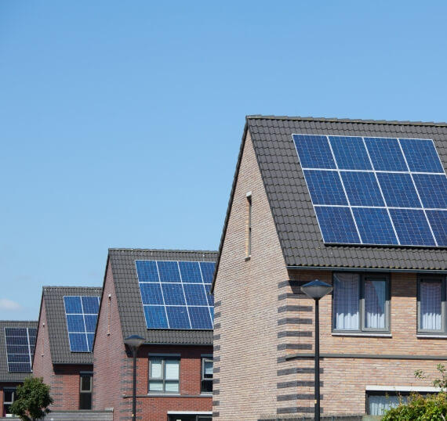
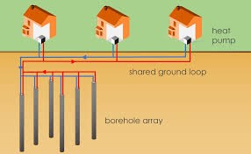
Solar Panels and GSHPs - Working in Tandem

Slide 11
Using Mine Waters as a Heat Source for GSHP

CDP Policy 5: “opportunities for a district heating network will be explored given the site's proximity to Lanchester Road Hospital and Aykley Heads”
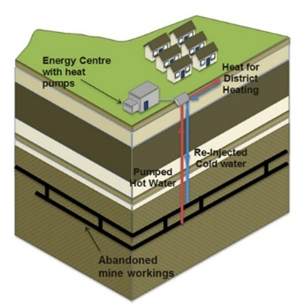
Slide 12

Sniperley – Mine Heat Feasibility Review for Durham County Council
September 2022: Desktop Coal Authority Report: Risks and Uncertainties
Mine water temperature – There is a lack of mine water temperature data within the shallow workings but could be inferred from the geothermal gradient for the area.
Available flow – There is no recent pumping test data for the abandoned workings in their present state.
Mine water chemistry – There is a lack of shallow groundwater chemistry evidence.
Gathering more site-specific information, will form part of both a Stage 2 assessment, and as part of a pilot drilling campaign

Slide 13

Solar Panels with Ground Source Heat Pumps working in Tandem

Grid Linked Solar panels work well in tandem with a ground source heat pump

An array of 20 solar panels generates approximately 20 kWh on a good day
and
Around 4,500 kWh of electricity throughout the year.

Slide 14

Solar Panels with Ground Source Heat Pumps working in Tandem

A ground source heat pump can achieve efficiencies of up to 400%.

Operating in tandem they could create 80 kWh on a good day and

around 18,000 kWh of energy per year, enough for most domestic houses.

At present day energy charges this amounts to £5,400 per year.

Slide 15

Unit Costs

The unit cost of installing this paired system for a single house is:

about £6,500 for a solar installation

plus £2,600 for a battery

and £11,800 for a ground source heat pump

that is about

£20,000 in total

a countywide £500 million project

Slide 16
Energy Security

A combined renewable energy system should pay for itself in less than 4 years.

The net cost of £20,000 should not be this high when applied to its introduction into 1,750 new build properties where the installation is prograde, rather than retrograde.

The size of this £35 million project should also reduce the unit costs significantly

The house owner gains energy security

Slide 17
Viability of Sniperley for Introducing Renewable Energy
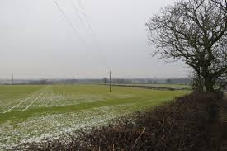
Slide 18
Suitability of Proposed Sniperley Housing for Renewable Energy
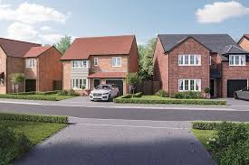
Slide 19
Suitability of Sniperley Housing for Renewable Energy
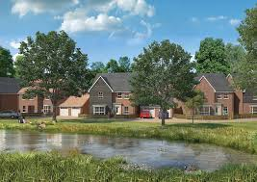
Slide 20
THE DEFINITIVE POLICIES THAT APPLY TO SNIPERLEY
AT SNIPERLEY THERE ARE 27 CDP POLICIES
THEIR CONSTRAINTS MUST BE MET BEFORE
THE DEVELOPERS’ PLANS CAN RECEIVE PLANNING PERMISSION
FOR EXAMPLE
POLICIES 5, 29 AND 32

Slide 21
Policy 5 - Durham City's Sustainable Urban Extensions
To meet housing need and to promote sustainable patterns of development, land at Sniperley Park is allocated for planned urban extensions and will be removed from the Green Belt.

Development must be comprehensively master planned

The proposed development must be sustainable

Slide 22
Policy 29 Sustainable Design

c. Minimise greenhouse gas emissions, by seeking to achieve zero carbon buildings and providing renewable and low carbon energy generation and include connections to an existing or approved district energy scheme where viable opportunities exist. Where connection to the gas network is not viable, development should utilise renewable and low carbon technologies as the main heating source.

This Policy applies to Sniperley Park and is in the Masterplan
Renewable energy must be used in all its buildings

The means to achieve this are already there

Slide 23

Policy 32 - Contaminated and Unstable Land

Development will not be permitted unless the developer can demonstrate that:
a. unstable land issues can be satisfactorily addressed by appropriate mitigation measures prior to the construction
Core principle
5.334 The effects of land instability may result …subsidence or ground heave. Failure to deal with land stability issues could cause risks to human health, local property and associated infrastructure…. Within County Durham the principal issue which relates to ground instability relates to past coal mining. Large parts of County Durham have been identified by the Coal Authority as 'Development High Risk Areas'.
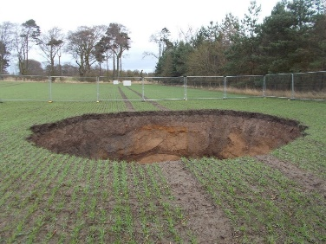

Slide 24
Sniperley Park’s bedrock consists of former coal seams
that have been worked
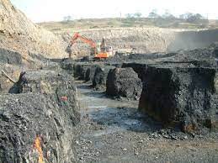 Pillar and Stall workings now uncovered for open cast removal
Slide 25
Policy 32 and Sniperley Park
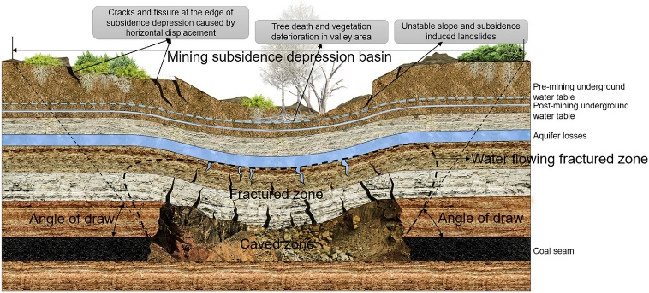

Slide 26

SNIPERLEY PARK
A GOLDEN OPPORTUNITY
FOR AN ENERGY SECURE ESTATE

SO, WHAT COULD GO WRONG?

Slide 27
A PARTING OF THE WAYS
THE DEVELOPERS WANT TO BUILD AT LEAST 1750 HOUSES AND DO IT THEIR WAY
THE OLD WAY
THE COUNTY COUNCIL WANT 1750
HOUSES AS PLACES TO LIVE
USING NEW PLANNING POLICIES
THE TWO OF THEM DON’T AGREE
THE MATTER WILL BE RESOLVED AT A PUBLIC INQUIRY IN JANUARY 2023

Slide 28
Key Moments

Sept 6th County Council Planning Committee confirms the officers’ recommendation to refuse applications. Bellway argue for time and that “officers’ hands have been tied behind their backs”
Sept 21st CDPC, WRRAG, CDT and CPRE meet to arrange Statement of Case. WRRAG miss the deadline
Sept 28th Bellway’s Statement of Case argues that the “Council has had sufficient opportunity to consider revised proposal”
Oct 6th Case Management Conference. Argument between Appellants and Council concerning the changing nature of the Appellants plans
Oct 11th Durham LLP admit to Council that “in early May we had decided to appeal”
Oct 24th Inspector rejects the Appellants’ argument to change the plans after having begun an Appeal
Oct 28th Rule 6 (CDPC, CDT, CPRE) meeting to confirm and co-ordinate their submissions to the Appeal in January
Oct 31st Rule 6 meeting with County Council officers to confirm and co-ordinate their common ground in the preparation for and submission to the Appeal.

Slide 29
THANK YOU

ANY QUESTIONS

OR OBSERVATIONS

